Design Document

Turku

1. Components introduction

1.1 Arduino

The Arduino Mega 2560 is a master development board based on the ATmega2560. The Arduino Mega2560 is a core circuit board with a USB interface, with 54 digital inputs and outputs, it is suitable for designs that require a large number of IO interfaces. And the processor core is the ATmega2560, which has 54 digital input/output ports, 16 analog inputs, 4 UART interfaces, a 16MHz crystal oscillator, a USB port, a power socket, an ICSP header, and a reset button. There are all resources on the board supporting one master board. It can automatically select 3 power supply modes: external DC power supply through the power socket; battery connected to the power connector GND and VIN pins; USB interface DC power supply.

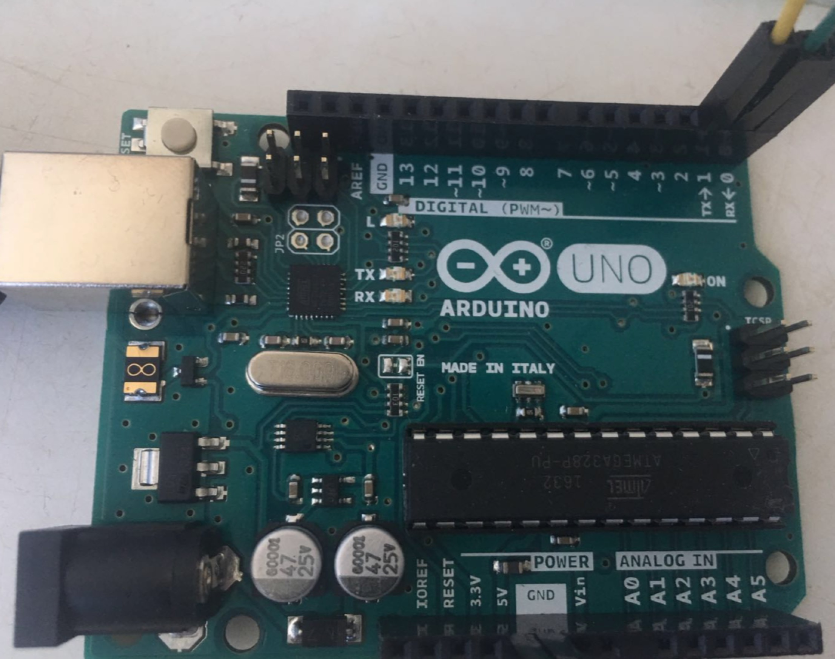

1.2 Sensor AM2302

1.2.1 Basic Introduction

AM2302 Humidity Capacitive Digital Temperature and Humidity Module is a temperature and humidity composite sensor that contains a calibrated digital signal output. It applies a dedicated digital module acquisition technology and temperature and humidity sensing technology to ensure that the product has high reliability and excellent long-term stability.

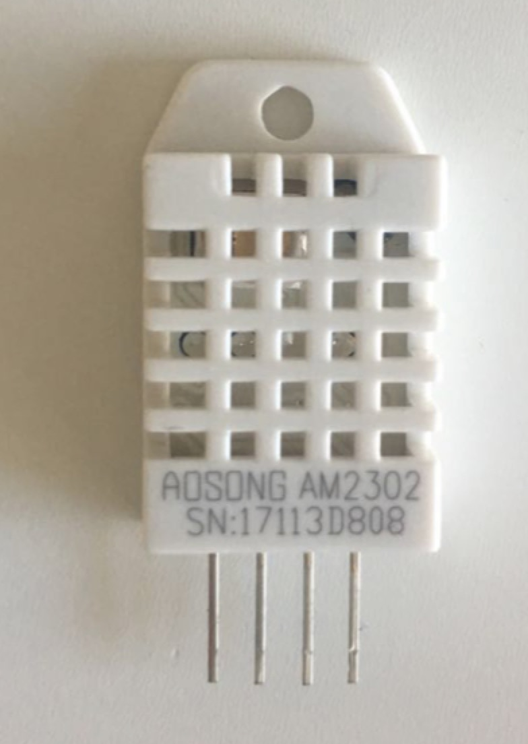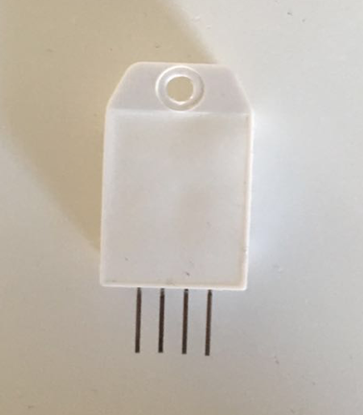

1.2.2 Product parameters:

Size: 40\*23mm

Weight: 4g

Voltage: 5V

Port: Digital Bidirectional Single Bus

Temperature range: -40-80°C ±0.5°C

Humidity range: 20-90%RH ±2%RH

Platform: Arduino, Microcontroller

1.2.3 Connection to the Arduino board:

The “VCC” of the module is terminated with a +5V output, the “GND” is terminated with a GND, and the “DAT” is terminated with a digital port with pin number 2 (of course, this can define the digital pin by itself).

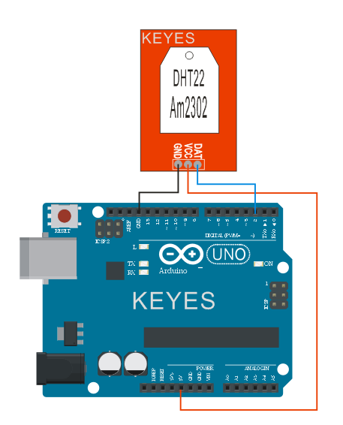

1.3 HC-05 Bluetooth Module

1.3.1 Introduction

The bluetooth HC-05 is a bluetooth module that can be connected to an arduino device. The bluetooth module makes it possible to achieve serial data transmission wireless and the interface is set to serial which makes it easy to implement in projects.

The module operates on the 2,4GHz ISM (industrial, scientific, medical) frequency band, such as NFC, WiFi networks, Microwave ovens etc. The device uses Bluetooth 2.0+EDR standard. This standard is specification for short-range communication, the EDR stands for Enhanced Data Rate, which is a faster PSK modulation scheme which makes it possible to transmit data 2 or 3 times faster than previous versions of bluetooth. The specifications mean that the HC-05 has a maximum transmission rate at 2.1Mbit/s. The signal transmit time is set to 0.5 seconds intervals for different devices so the workload of the chip is reduced.

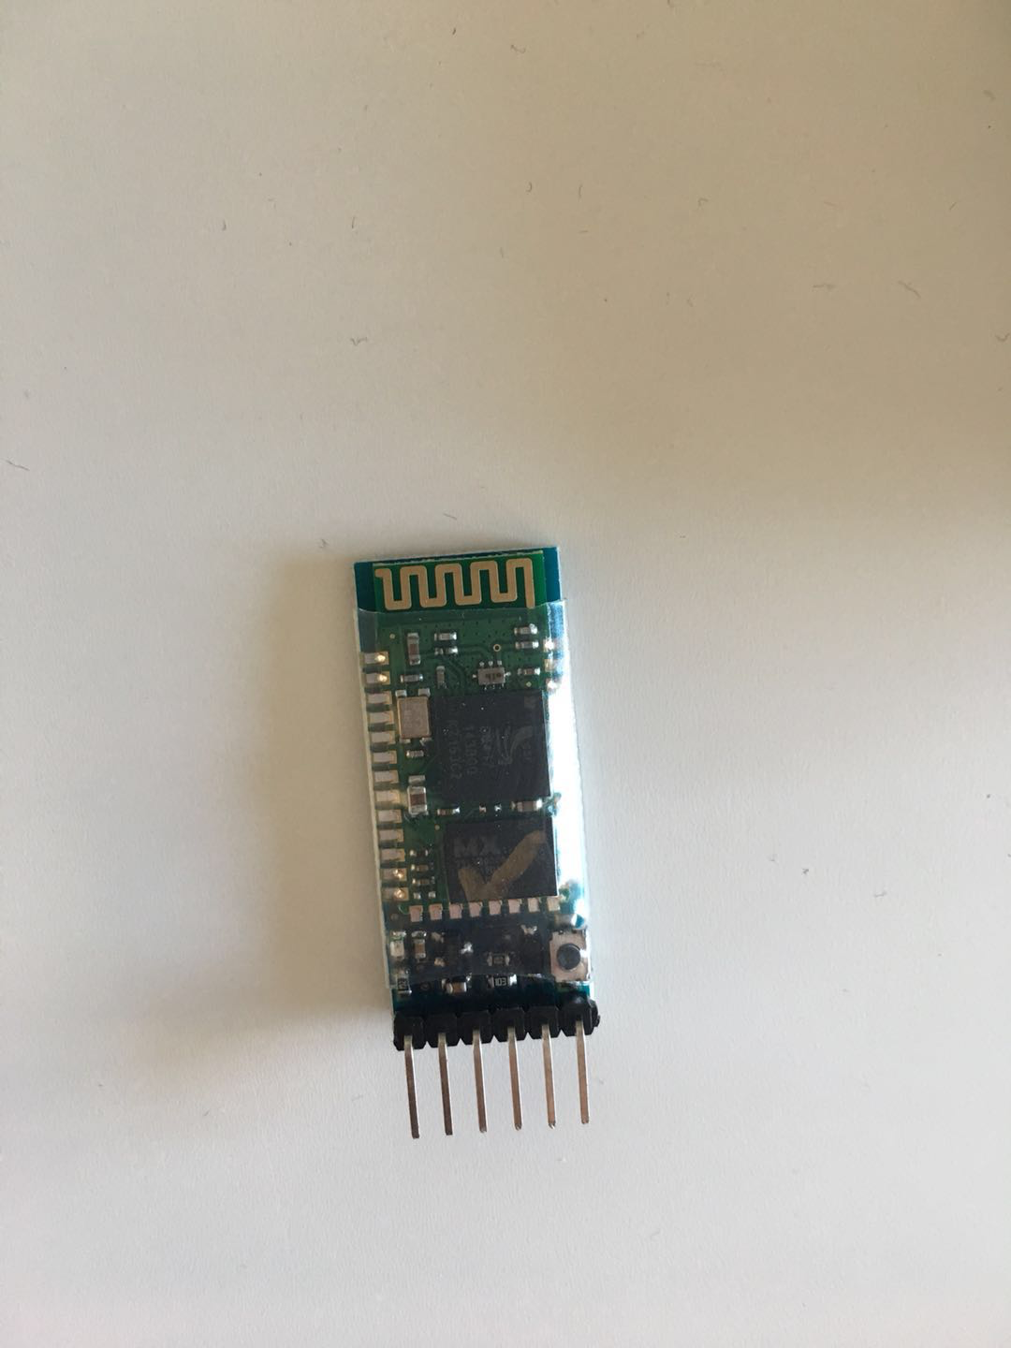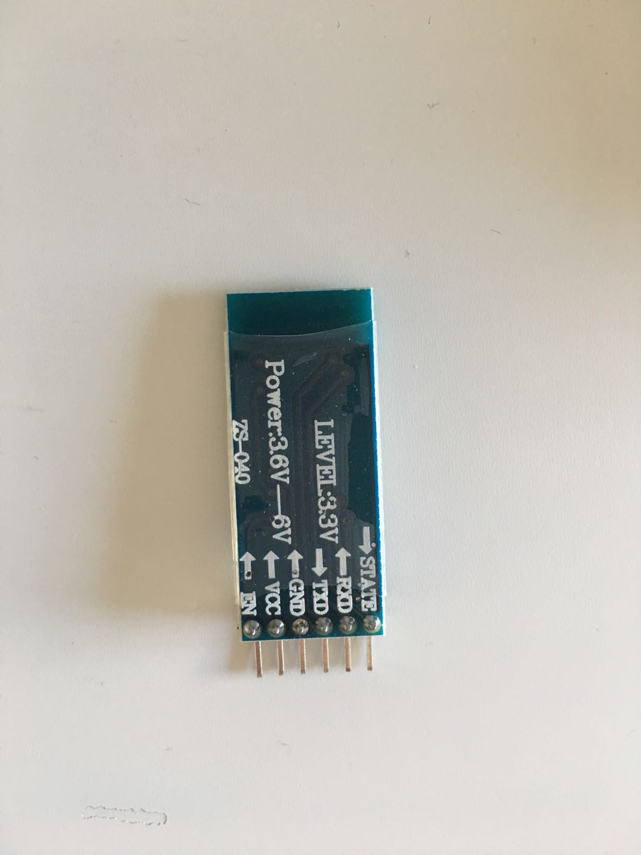

The module has the following default settings:  
Baud-rate: 9600 (Common data rate config with: no parity bit, 8 data bits and 1 stop bit)  
Standard-pin: 1234

Standard name: HC-05

2. System integrity

2.1 Hardware requirements:

Arduino Controller × 1

USB data cable × 1

DHT22 module × 1

HC-05 module× 1

2.2 Overall Circuit Schema

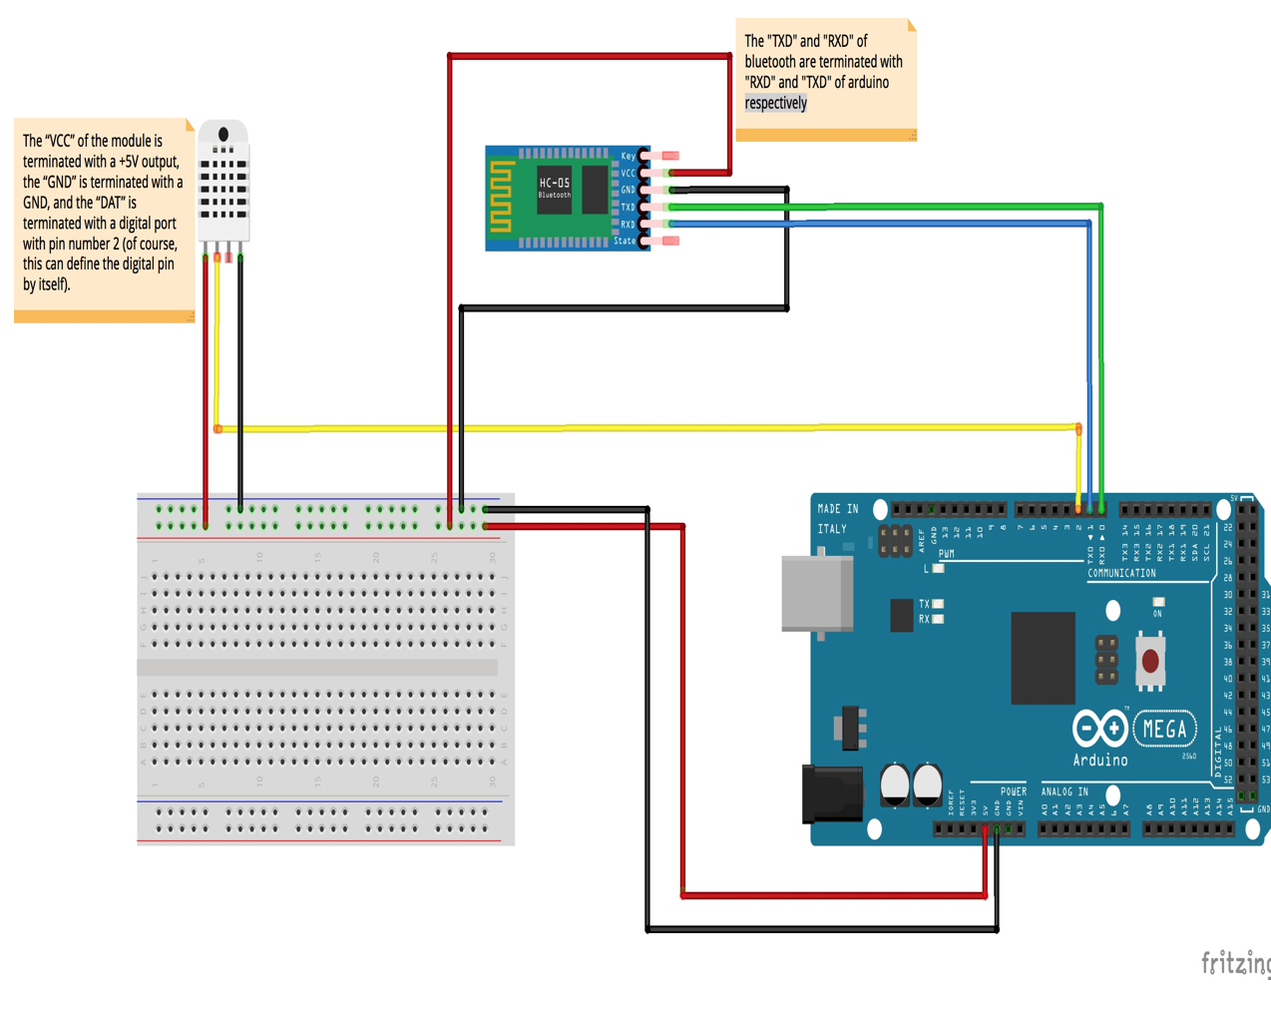

Circuit schema

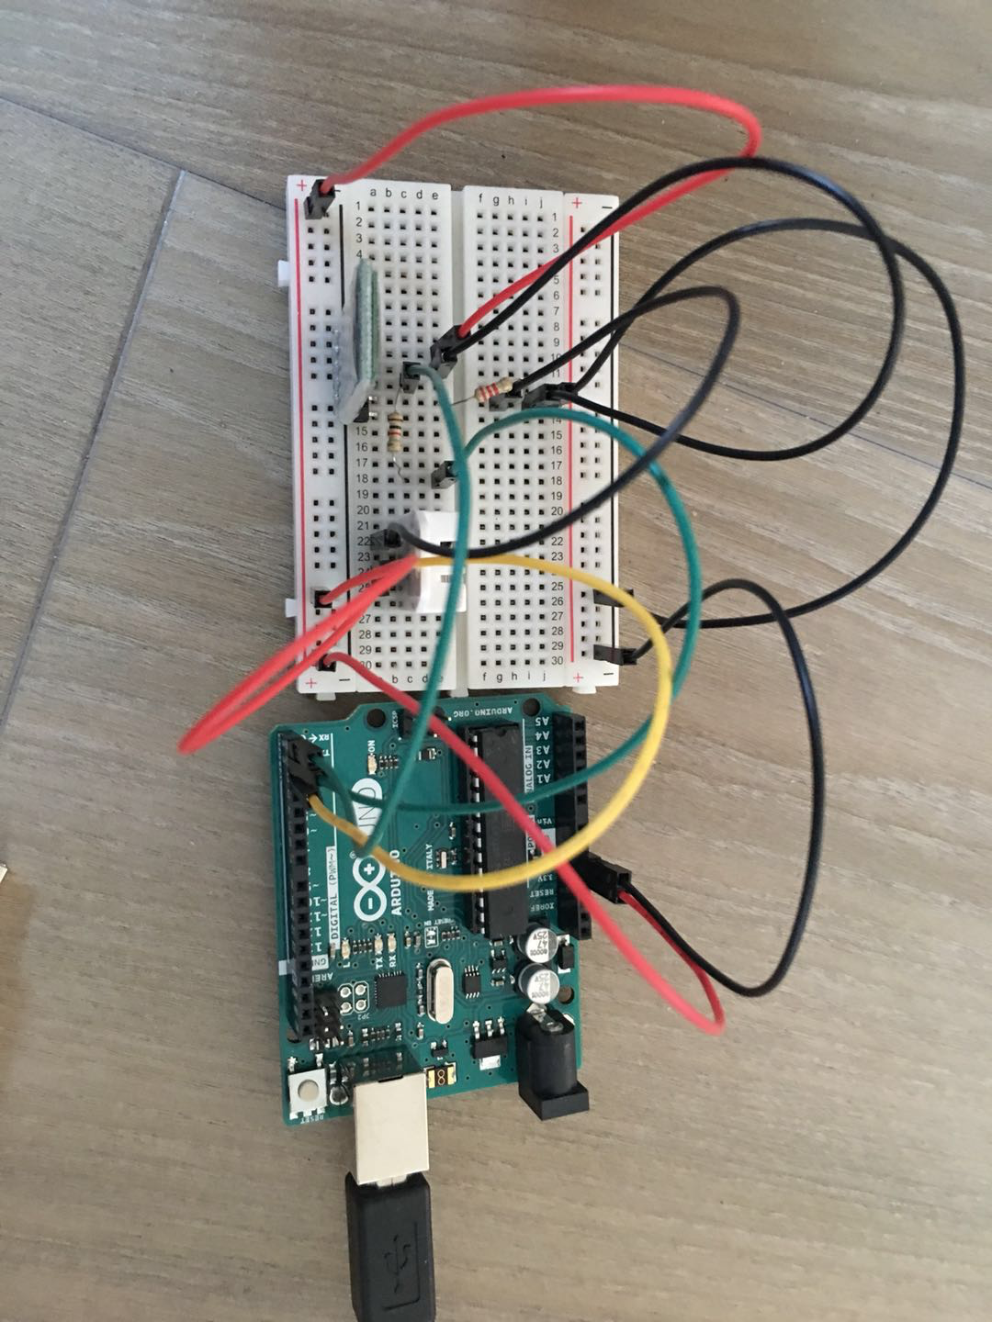

Physical circuit schema

3 Working flow

First, connect the wires each component according to the method above, connect HC-05 Bluetooth to the server by using UART, configure on the computer (because sever is not finished by other team members, so we test in local), remember to check the COM port consistent with the COM port of python file, and run the python file, the server can receive the values of sensor.

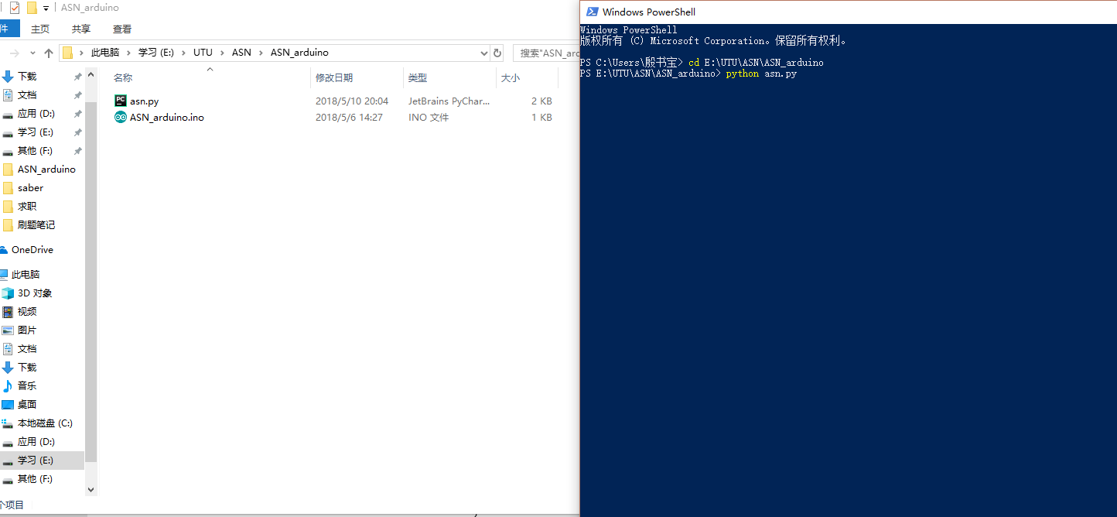

Then we can see the value of humidity and temperature on the terminal, and note that JSON file is success created.



After using my mouth to blow hot air on the sensor, the temperature and humidity have changed obviously.



And you can see test.json in the folder.

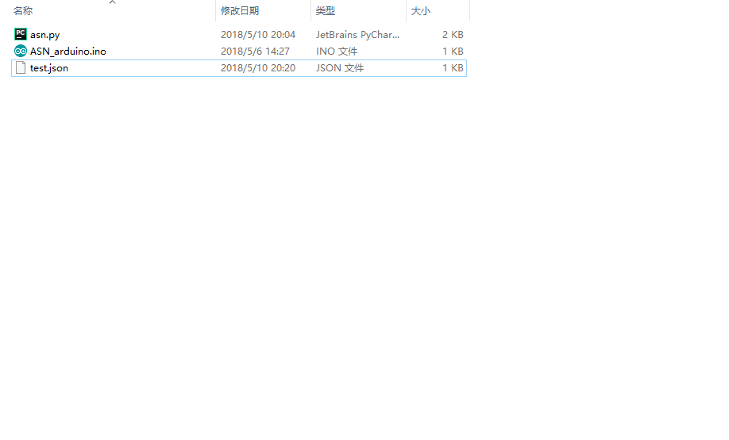

open the test.json, you can see the current value of humidity and temperature.

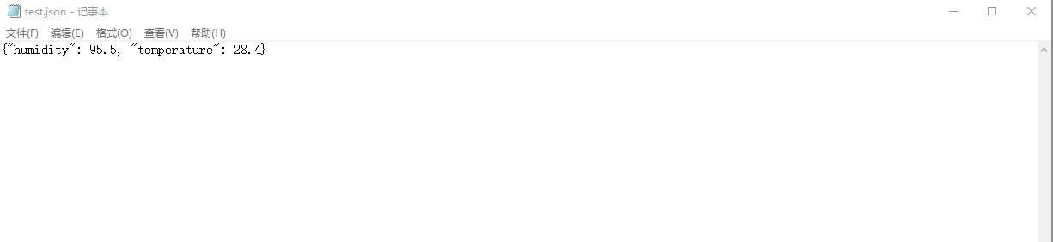

Note:

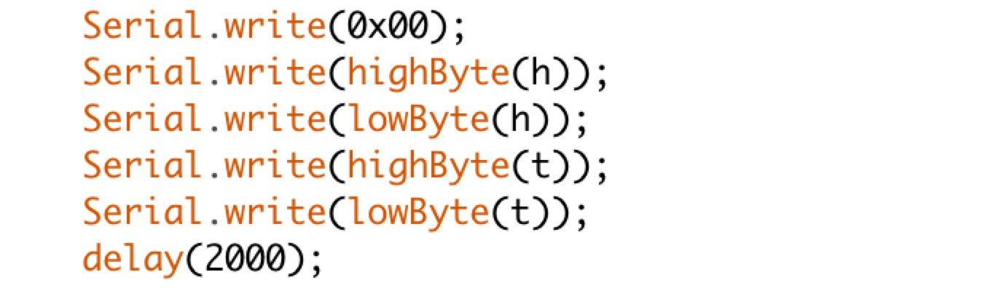

We totally send 5 bytes data from Arduino write to the serial, 0x00 is the start byte, second and third bytes are the value of humidity, while fourth and fifth bytes are the value of temperature.

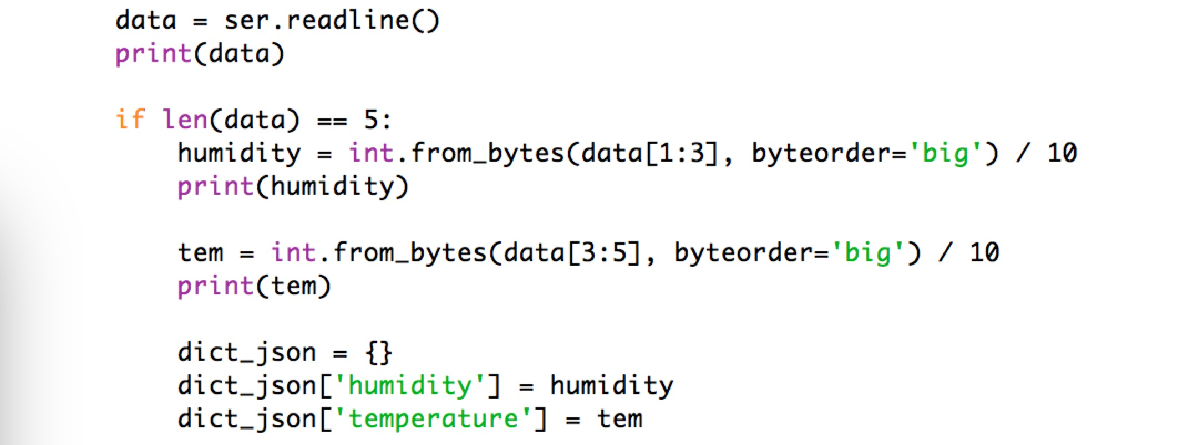

In python file, read from corresponding bytes for humidity and temperature, convert these values to integer, then transform to json format.